Eco Wise AI -Personal Sustainability Coach

Project Report

AI Sustainable Development Goals Internship 2026

Submitted by

Srudhya S

Ayesha Afroze M

Pooja Shree S S

College Name: Shrimathi Devkunvar Nanalal Bhatt Vaishnav College for Women

Department: BSC Computer Science with Artificial Intelligence

Table of contents

S.NO | Topic
1 | Abstract
2 | Introduction
3 | Problem Statement
4 | Objectives
5 | Scope of the Project
6 | Literature Survey
7 | Methodology
8 | Result
9 | Future Scope
10 | Conclusion
11 | References

ABSTRACT

Eco Wise AI is an intelligent sustainability assistant designed to promote environmentally responsible behaviour. The system provides personalized guidance on water conservation, energy efficiency, waste management and climate action. By leveraging AI-powered recommendations through prompt engineering and the Groq API, users can make informed decisions that reduce resource consumption and environmental impact. The application is built using Python and Streamlit, making it accessible through any web browser without requiring complex setup.

INTRODUCTION

- Environmental sustainability has become one of the most pressing challenges of the 21st century. Climate change, water scarcity, energy depletion and increasing waste generation are threatening ecosystems and human wellbeing worldwide. Despite growing awareness, many individuals lack access to simple, personalized guidance on how to adopt sustainable habits in their daily lives.
- Eco Wise AI addresses this gap by providing an AI-powered sustainability coach that is freely accessible, easy to use and capable of answering questions in natural language. The application covers four critical sustainability domains aligned with the United Nations Sustainable Development Goals (SDGs): Water Conservation (SDG 6), Energy Saving (SDG 7), Waste Management (SDG 12) and Climate Action (SDG 13).

- Unlike traditional information portals, Eco Wise AI uses conversational AI to provide context-aware, personalized responses. Users can ask questions, seek tips or simply have a conversation about sustainability __ all in a friendly, jargon-free manner.

PROBLEM STATEMENT

Despite the availability of sustainability information online, several barriers prevent individuals from adopting eco-friendly practices:
- Information overload: Thousands of websites provide conflicting or overly technical sustainability advice.
- Lack of personalization: Generic tips do not address individual circumstances or specific questions.
- Low engagement: Static articles and reports fail to engage users in meaningful conversations.
- Accessibility: Many sustainability tools require technical knowledge or paid subscriptions.
- Language barriers: Most resources are available only in English or use complex scientific terminology.

Key statistics that highlight the urgency of this problem:
- Around 2.2 billion people lack access to safely managed drinking water (UN SDG 6).
- Energy efficiency is one of the fastest ways to reduce greenhouse gas emissions (IEA).
- Food waste contributes significantly to global greenhouse gas emissions (EPA).
- Earth's average temperature has risen by approximately 1 degree Celsius since the late 19th century (NASA).

Eco Wise AI solves these problems by providing a free, conversational, AI-powered sustainability coach that gives personalized, simple and actionable guidance to anyone with an internet connection.

OBJECTIVES

The primary objectives of Eco Wise AI are:
- To promote sustainable living practices among general users through accessible AI-powered guidance.
- To educate users about key environmental challenges including water scarcity, energy consumption, waste generation and climate change.
- To provide personalized sustainability recommendations based on user queries using prompt engineering.
- To encourage responsible resource usage through conversational interaction.
- To support global sustainability goals aligned with UN SDGs 6, 7, 12 and 13.
- To demonstrate the practical application of AI in environmental education without complex infrastructure.

SCOPE OF THE PROJECT

The application focuses on four major sustainability domains:

1. Water Conservation (💧)
2. Energy Conservation (⚡)
3. Waste Management (♻️)
4. Climate Change Awareness(🌍)

LITERATURE SURVEY

Several existing tools and research works inform the development of Eco Wise AI:

UN Sustainable Development Goals (SDGs)
The United Nations defined 17 Sustainable Development Goals in 2015 as a universal call to action to end poverty, protect the planet and ensure peace and prosperity. Eco Wise AI directly addresses SDG 6 (Clean Water), SDG 7 (Clean Energy), SDG 12 (Responsible Consumption) and SDG 13 (Climate Action). These goals provide a globally recognized framework for measuring the impact of sustainability education tools.

Environmental Protection Agency (EPA) Resources
The EPA provides comprehensive resources on water conservation and waste management. Their guidelines emphasize the three pillars of waste reduction — Reduce, Reuse and Recycle — which form the basis of Eco Wise AI's waste management module. EPA data on household water usage and leak prevention directly informs the water conservation prompts used in the system.

NASA Climate Research
NASA's climate research portal provides scientifically validated data on global temperature trends, greenhouse gas concentrations and sea level rise. Eco Wise AI's climate action module draws on this data to provide accurate, science-based responses to user questions about climate change. NASA reports that carbon dioxide levels are higher than at any point in the last 800,000 years, underscoring the urgency of climate education.

International Energy Agency (IEA)
The IEA's energy efficiency reports highlight that improving energy efficiency is one of the most cost-effective ways to reduce greenhouse gas emissions. Their data on LED lighting adoption and renewable energy growth informs the energy saving recommendations provided by Eco Wise AI.

Conversational AI in Education
Recent research demonstrates that conversational AI tools significantly improve user engagement with educational content compared to static websites. Studies show that users who interact with chatbots for learning retain information more effectively and are more likely to apply what they learn. Eco Wise AI applies these findings by using a chat-based interface rather than a traditional web portal.

METHODOLOGY

System Architecture
Eco Wise AI follows a simple and efficient architecture without complex components such as RAG pipelines or IoT integrations:
Component | Description
User Interface | Streamlit web application with black-themed design
Topic Detection | Keyword-based classification into 4 sustainability topics
Prompt Engineering | Topic-specific system prompts with research-backed facts
AI Model | Llama 3.3 70B via Groq API (free tier)
Image Analysis | Llama 4 Scout Vision model via Groq API
Deployment | Streamlit Cloud (free hosting)

Topic Detection
When a user submits a question, the system uses keyword matching to classify it into one of four topic categories: Water Conservation, Energy Saving, Waste Management or Climate Action. Each category has an expanded keyword list derived from domain-specific research. A tie-breaker mechanism handles cases where multiple topics score equally by selecting the first matching keyword in sequence.

Prompt Engineering
Each topic has a dedicated system prompt that incorporates:
- Key facts from authoritative sources (UN SDG, EPA, NASA, IEA).
- Role definition: the AI presents itself as a domain expert.
- Behavioural rules: tips are only provided when explicitly requested.
- Sample response formats to ensure consistent, actionable output.

Conversational Memory
Eco Wise AI maintains full chat history within each session using Streamlit's session state. The complete conversation history is passed to the AI model with each request, enabling context-aware follow-up responses. This allows users to ask follow-up questions naturally, as they would in a real conversation.

Image Analysis
Users can upload images (JPG, PNG, WEBP) for sustainability analysis. The system encodes the image in base64 format and sends it to the Llama 4 Scout vision model via the Groq API. The AI analyses the
image for environmental relevance and provides sustainability insights based on what it observes.

RESULT

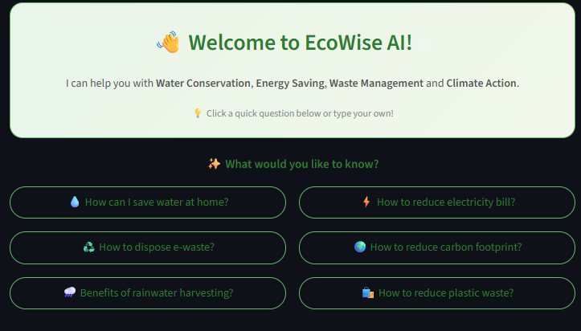

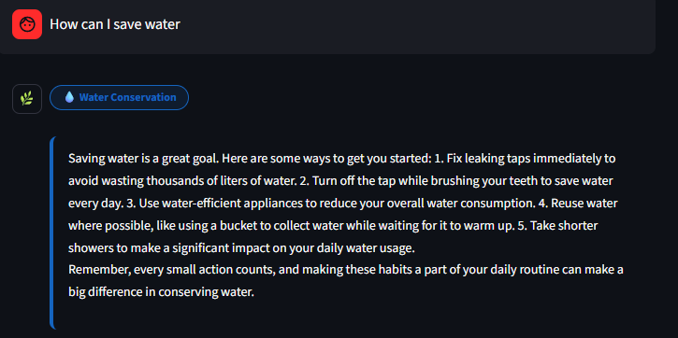

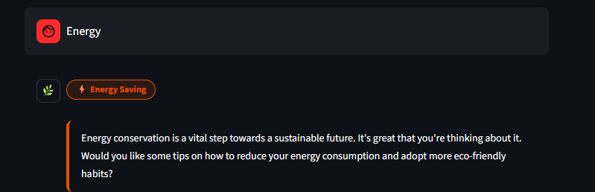

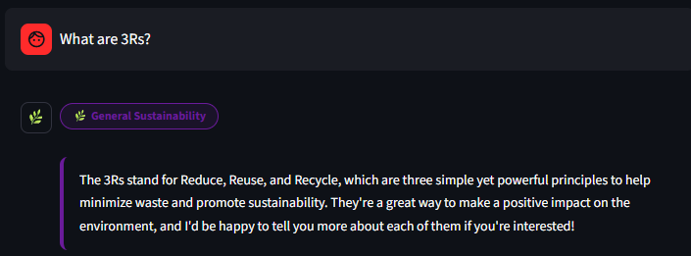



FUTURE SCOPE

The following enhancements are planned for future versions of Eco Wise AI:
- Multilingual support: Extend the application to support Tamil, Hindi and other regional languages to reach a wider audience.
- Voice input: Add speech-to-text functionality so users can ask questions verbally.
- Mobile application: Develop a dedicated Android and iOS app for better accessibility.
- RAG integration: Implement Retrieval-Augmented Generation to pull from a larger knowledge base of sustainability documents.
- Personalized profiles: Allow users to create profiles and track their sustainability progress over time.
- Carbon footprint calculator: Add an interactive tool to calculate and monitor personal carbon emissions.
- Community features: Enable users to share sustainability tips and achievements with others.

CONCLUSION

- Eco Wise AI successfully demonstrates how Artificial Intelligence can be used to promote environmental sustainability through an accessible and interactive platform. By integrating Prompt Engineering, the Groq API, and Streamlit, the application provides personalized guidance on water conservation, energy saving, waste management, and climate action. The project is aligned with United Nations Sustainable Development Goals (SDGs) 6, 7, 12, and 13, encouraging users to adopt environmentally responsible practices in their daily lives.

- The system was tested using sustainability-related queries and produced relevant, informative, and actionable responses. Its simple architecture, combined with effective AI-powered recommendations, makes it a practical solution for increasing sustainability awareness among students, households, and communities. The results demonstrate the potential of conversational AI in supporting environmental education and promoting sustainable behaviour.

- Overall, Eco Wise AI highlights how modern AI technologies can be applied to address real-world environmental challenges without requiring complex infrastructure or expensive resources. The project serves as a valuable example of using technology to create positive social and environmental impact while encouraging a more sustainable future.

REFERENCE

United Nations Sustainable Development Goals
- Goal 6: Clean Water and Sanitation (https://sdgs.un.org/goals/goal6)
- Goal 7: Affordable and Clean Energy (https://sdgs.un.org/goals/goal7)
- Goal 12: Responsible Consumption and Production (https://sdgs.un.org/goals/goal12)
- Goal 13: Climate Action
(https://sdgs.un.org/goals/goal13)

Environmental Protection Agency (EPA)
- Water Conservation Resources (https://www.epa.gov/watersense)
- Waste Management and Recycling Guidelines (https://www.epa.gov/recycle)

NASA Climate (https://climate.nasa.gov)
- Global Temperature Trends
- Greenhouse Gas Data
- Sea Level Rise Information

International Energy Agency (IEA) (https://www.iea.org/topics/energy-efficiency)
- Energy Efficiency Reports
- Renewable Energy Statistics
- Clean Energy Transition Resources

Technologies Used

- Python - https://python.org
- Streamlit - https://streamlit.io
- Groq API- https://console.groq.com/keys
- Llama 3.3 70B- Meta AI
- Llama 4 Scout Vision-Meta AI

